LAB ASSIGNMENT-3.3

AI Assisted coding

Name: K.Pardhasaradhi

Htno: 2403A52001

Task-1:

Description: Try 3 different prompts to generate a factorial function.

Prompt-1: Generate a python code to calculate a factorial function

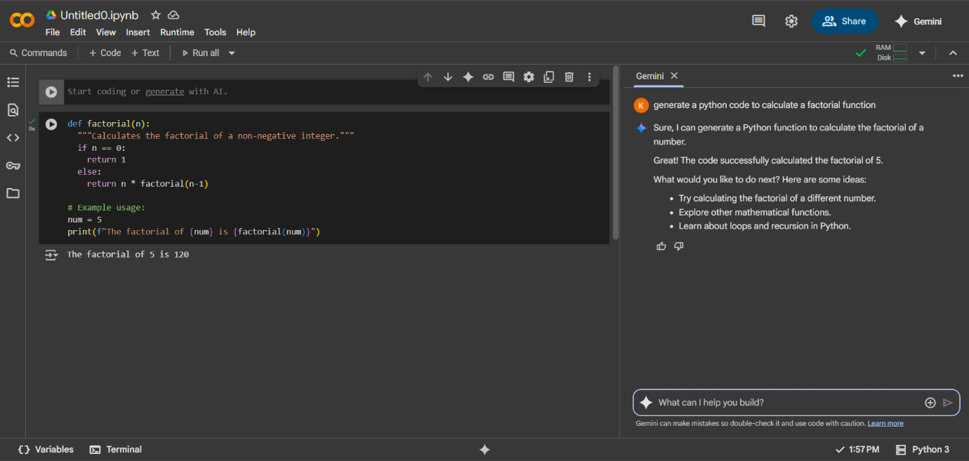

Prompt-2: Write a python script that aska the user for a number and prints its factorial using loop

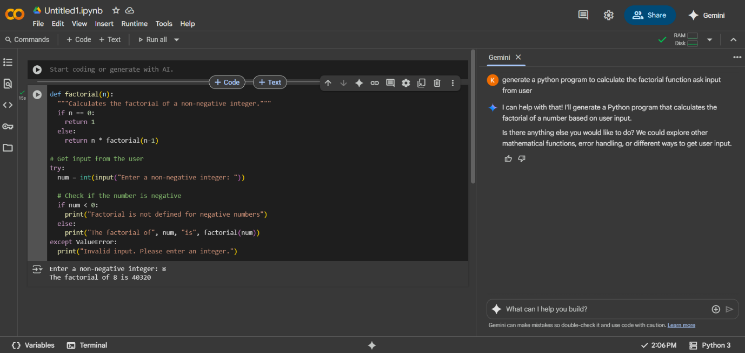

Prompt-3: Create a python function called factorial(n) that returns the factorial of n.

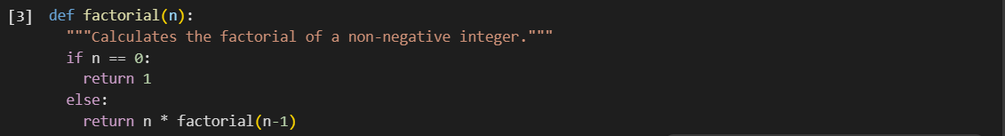



Observation: In this task I have used 3 different prompts to generate factorial function. when I use different prompts the AI also gives me different code based on the prompt.

Task-2:

Description: Provide a clear example input-output prompt to generate a sorting function.

Prompt: Write a simple python function that takes a list of integers and returns the same list sorted in ascending order.

Code:

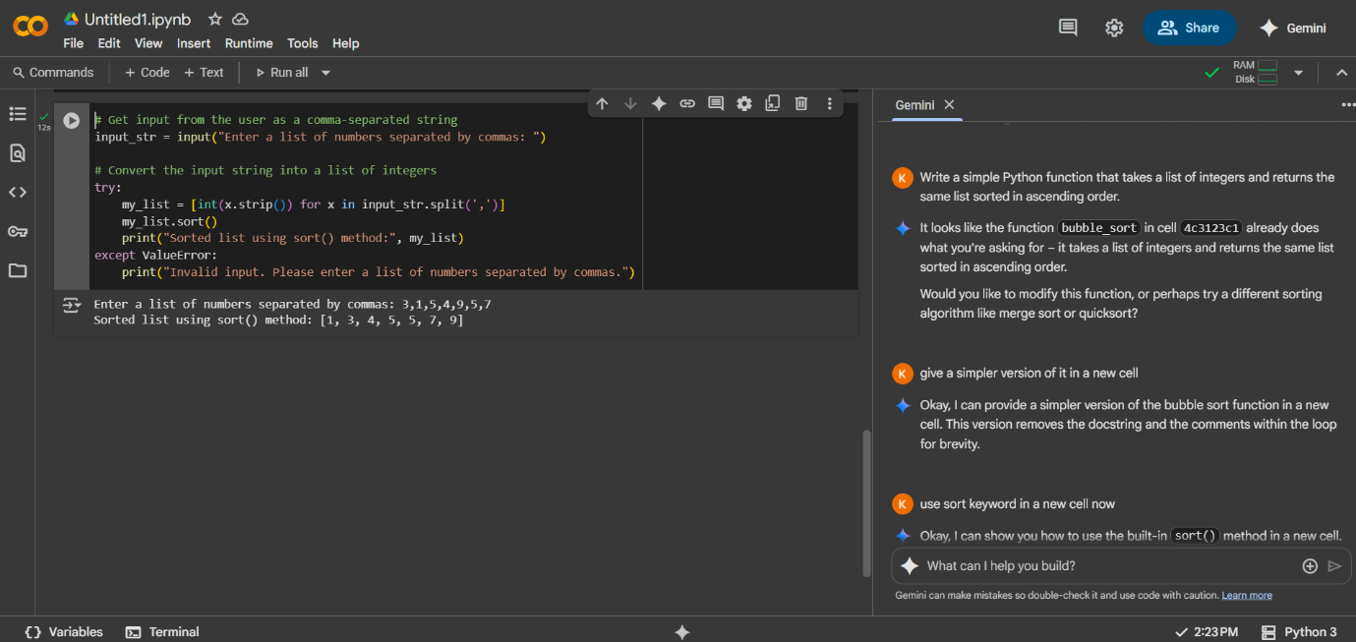

Observation: Gemini can understand the task very clearly. Gemini used try except made to sorted the given list and used sort() function.

Task-3:

Description : Start with the vague prompt “Generate python code to calculate power bill” and  
improve it step-by-step.

Prompt-1: Generate a python code to calculate power bill.

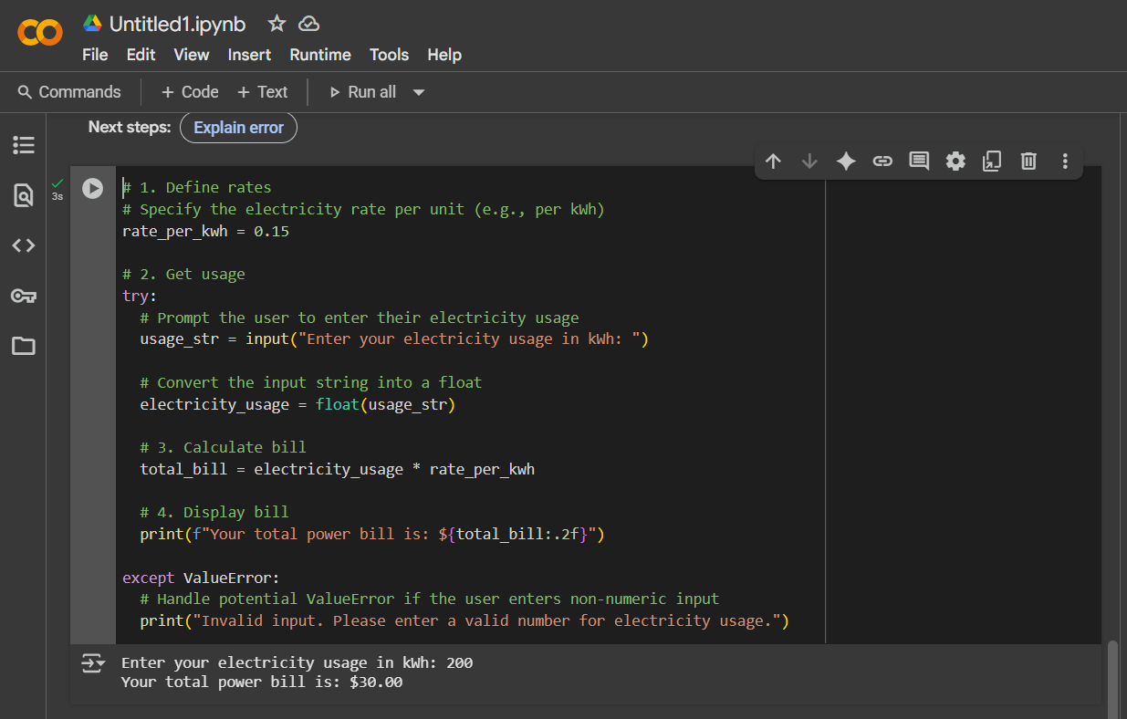

Prompt-2: Generate a python code to calculate power bill wit slabs +10% discount if units <100, 5% surcharge if >500.

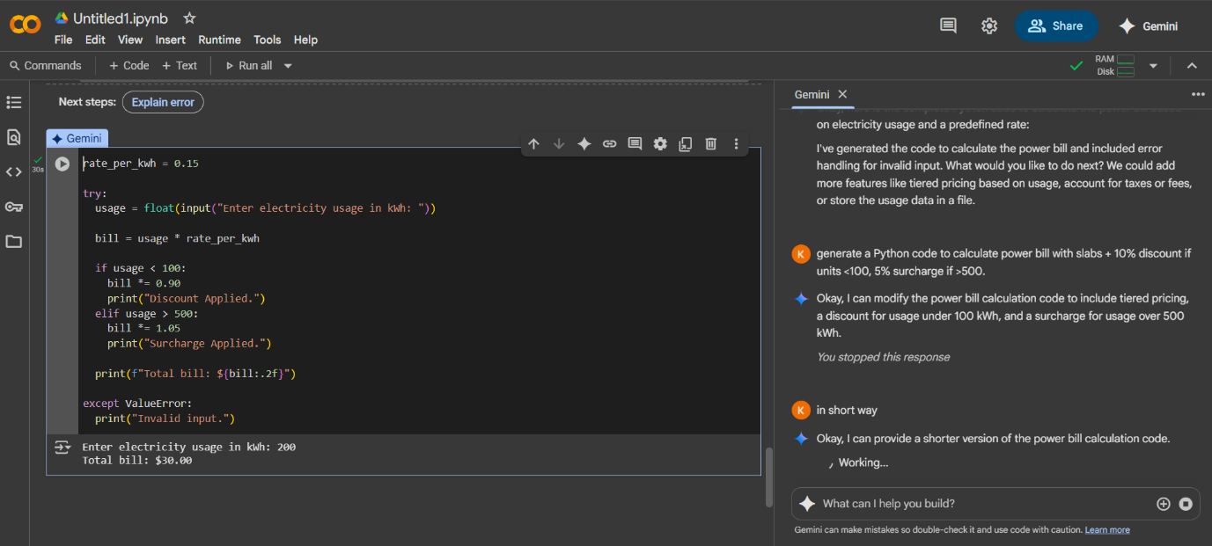

Prompt-3: Write a python that asks the user for the number of electricity units consumed. Use these slab rates : Frist 100 units for %5 per unit next 100 units for $7 per unit above 200 units for $10 per unit finally, print total bill.

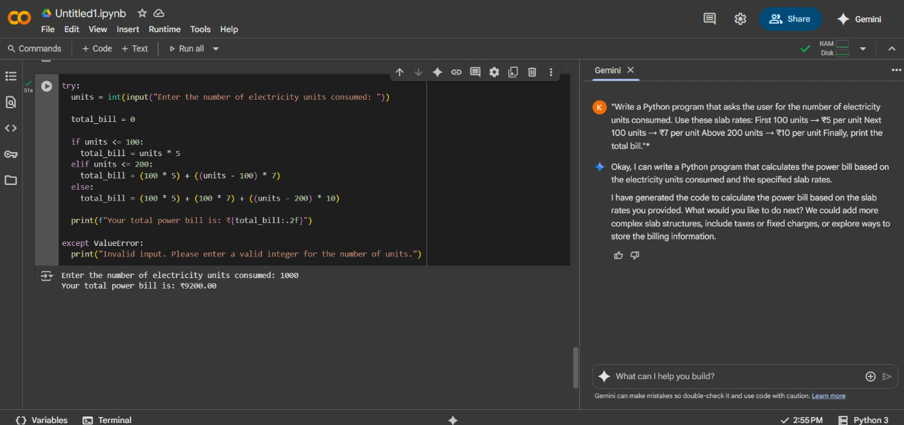

Observation: I have given different types of prompts by changing the electricity units conditions but the Gemini AI can easily given the code.

Task-4:

Description: Write structured comments to help AI generate two linked functions (e.g., login_user()  
and register_user()).

Prompt: Create a python program with two functions login_user() and register_user().Use a dictionary{ username, password} to store users .Add menu-driven loop where users can register like username, password, phnumber ,age ,clgname, login and quit.

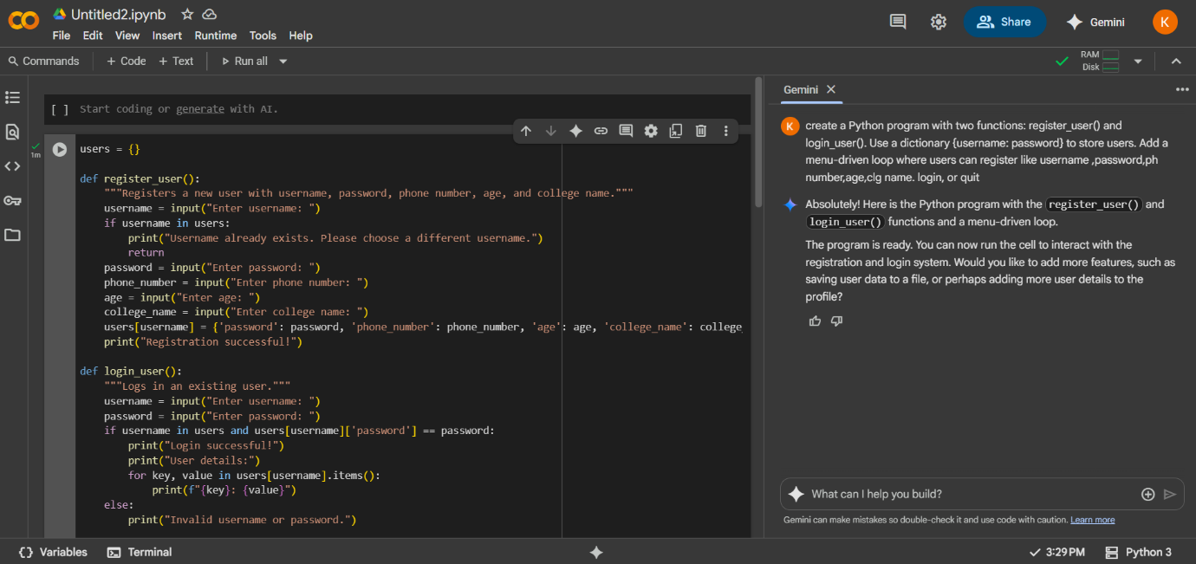

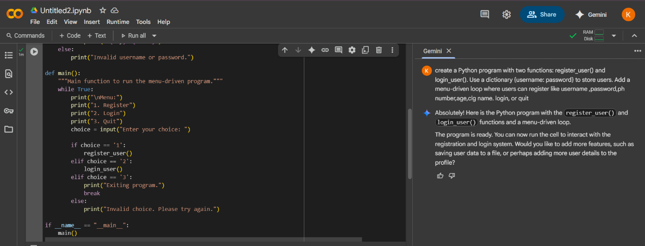

Output:

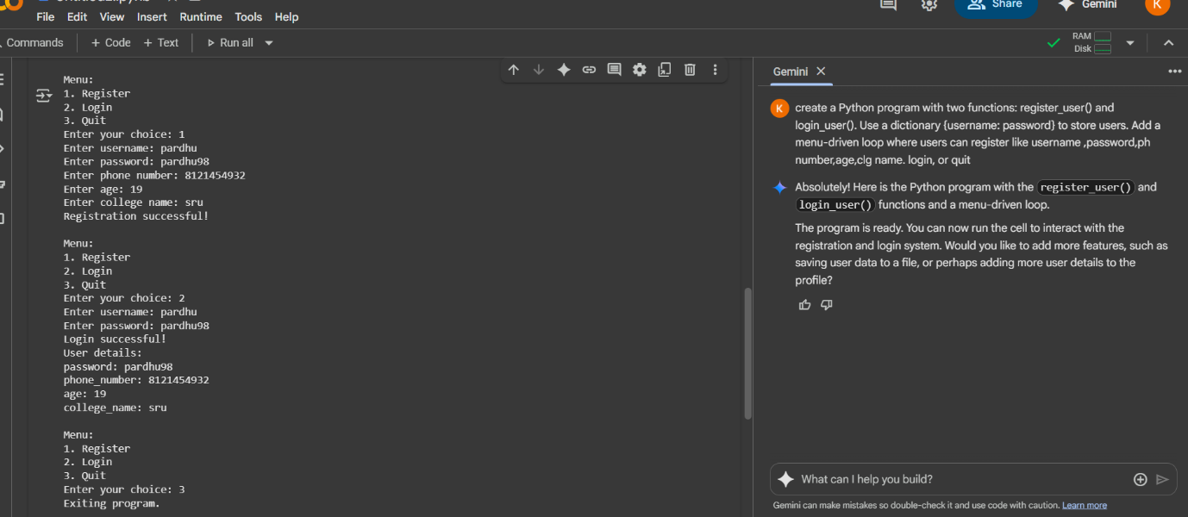

Observation: Gemini AI used two linked functions and Used dictionary to store username and password. It can understand my prompt very easily. It gives correct output.

Task-5:

Description: Analyzing Prompt Specificity: Improving Temperature Conversion Function with Clear Instructions.

Prompt: Write a python program that asks the user to choose conversion type ,accepts input, performs the conversion and prints the output.

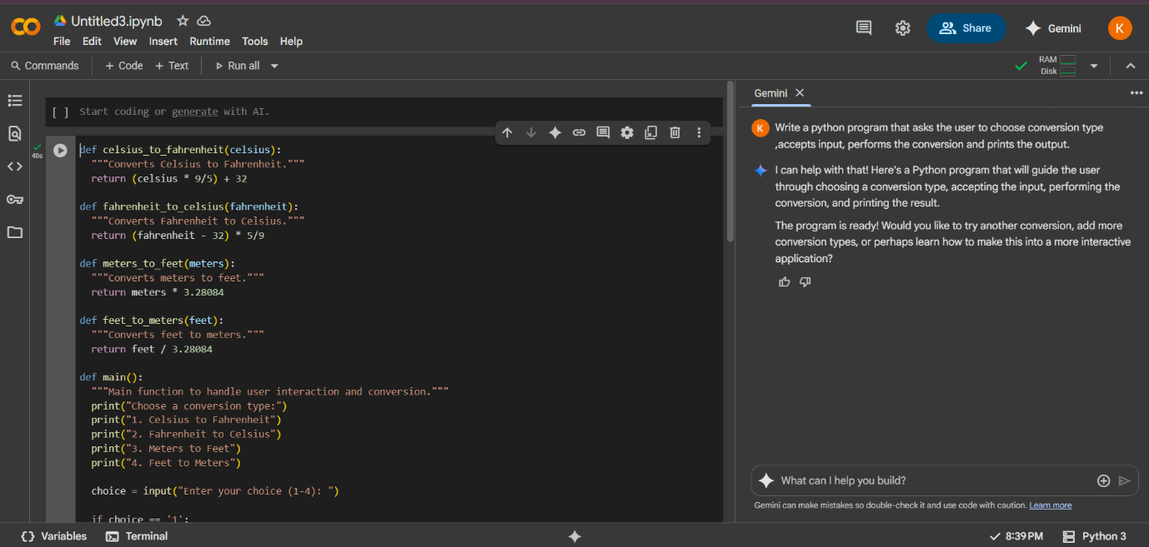

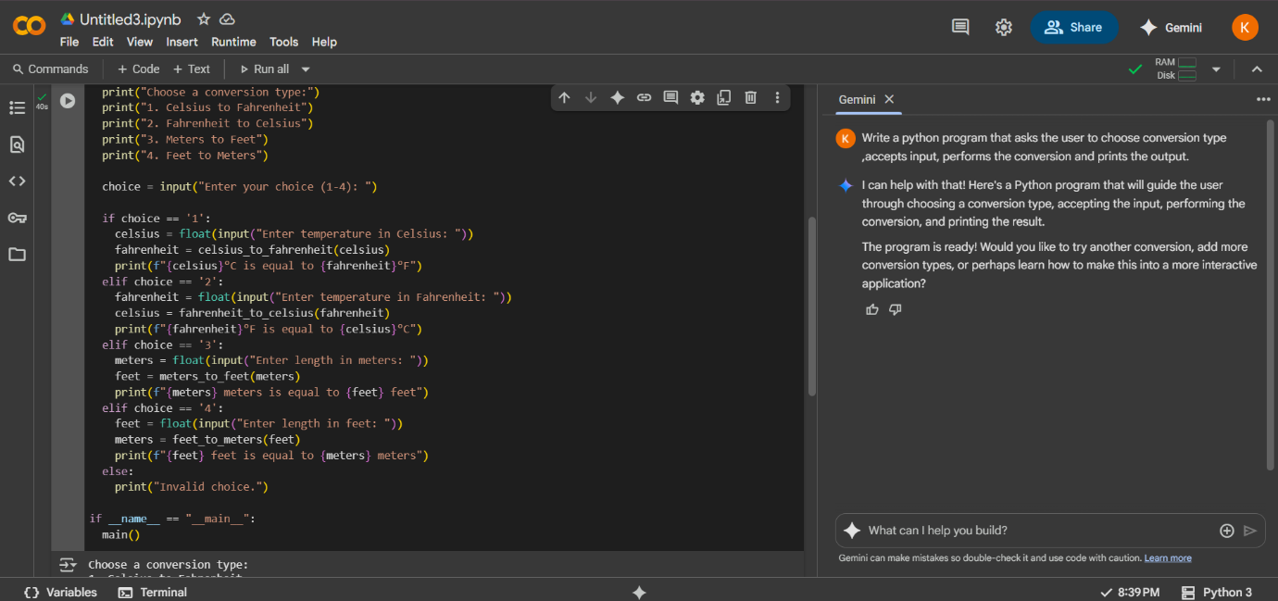

Output:

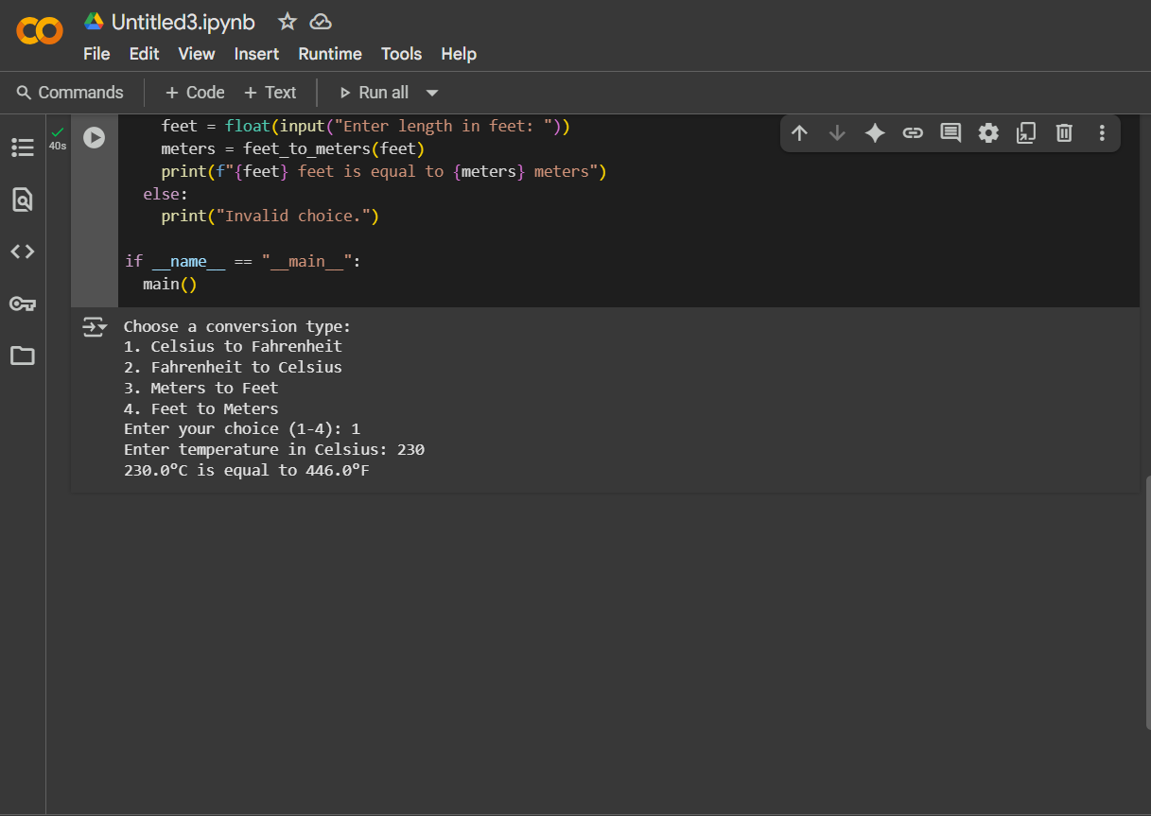

Observation: Gemini AI used functions and loops method .The code is understanding , clean, readable and clear . the output given by temperature symbols